OBE IMPLEMENTATION
PROGRAM LEVEL OBJECTIVE SETTING

by

Nikhil Sireesh Thalakola [ AP22110010009 ]
Mansoor Muzahid Shaik [ Ap22110010019 ]
Nagur Meeravali Shaik [ AP22110010061 ]
Ramgopal Mukhamatam [ AP22110010063 ]

A report for the CS307: Mobile Application Development using JAVA



DEPARTMENT OF COMPUTER SCIENCE AND ENGINEERING
SRM UNIVERSITY AP::AMARAVATI

INDEX

Introduction 3
Project Modules: 3
Architecture Diagram 4
Module Description 5
Programming Details naming conventions to be used: 5
Table details:(eg university)[you consider you module ] 5
Source Code 6
Screen Shots 12
Conclusion 14

Introduction
SRM University - AP is adopting OBE (Outcome Based Education). As part of this initiative, our team has been assigned the task of developing a Windows and Mobile Application using Java. The application supports CRUD (Create, Retrieve, Update, Delete) operations to manage and monitor OBE implementation data effectively.

Project Modules:
Various Modules available in the project are
- Blooms Level setting
- Program Level Objective Setting
- University
- Schools
- Department
- Programs
- Courses
- Course objective setting
- Course Outcome Setting
- Course Articulation matrix Setting
- Course Utilization Setting
- Course Reference Setting.

Architecture Diagram
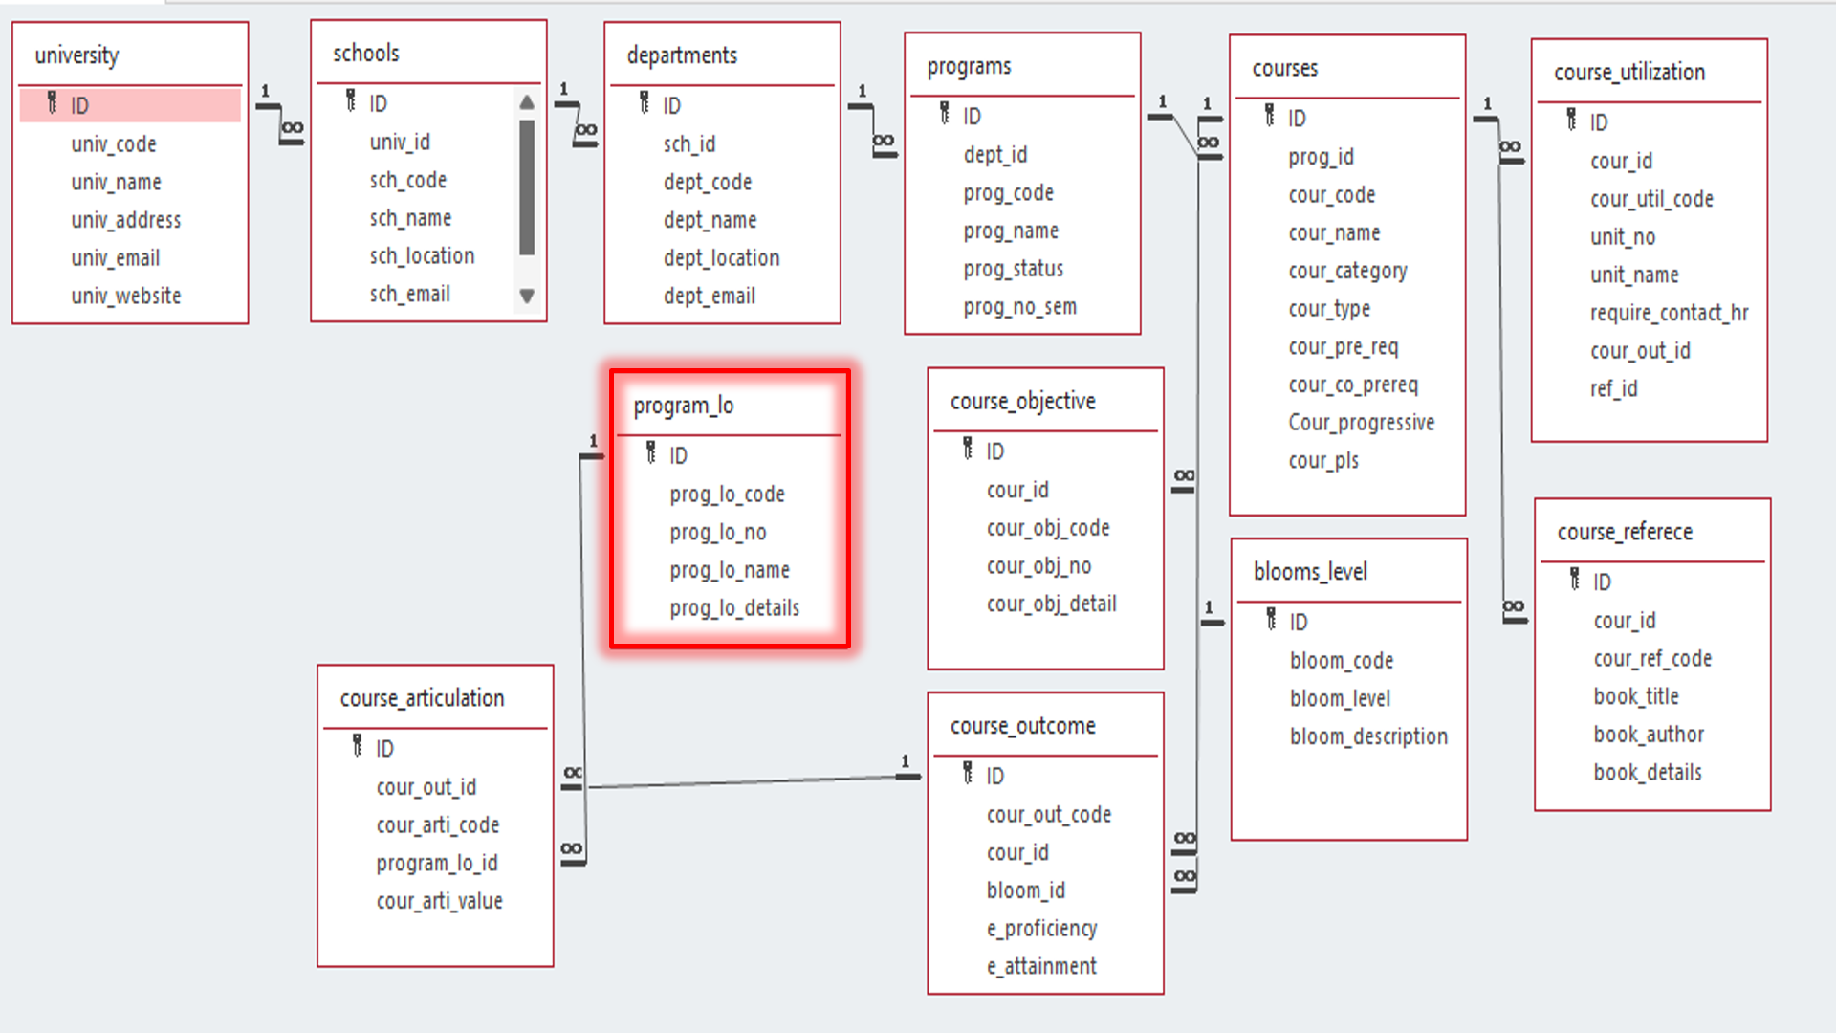

Module Description
Module Name: Program Level Objective (PLO) Setting
Module Description:
This module is designed to perform CRUD operations on Program Level Objectives. Users can create, edit, view, and delete program objectives using Windows. The data is stored in a relational database (e.g., SQLite/MySQL) for persistence.

Programming Details naming conventions to be used:
- class name/activity name: teamplo_program_level_objective_setting
- Function/method name
  - Create: TeamPLO_plo_create()
  - Update: TeamPLO_plo_update()
  - Retrieve: TeamPLO_plo_retrieve()
  - Delete: TeamPLO_plo_delete()

Table details: (program_lo)
Field Name | Data Type
ID | Integer
prog_lo_code | String
prog_lo_no | String
prog_lo_name | String
prog_lo_details | String

Source Code
DBConnection

package teamplo_program_level_objective_setting;

import java.sql.*;

public class DBConnection {
private static Connection conn;
private static Statement stmt;

public static void connect(String dbName) {
try {
Class.forName("org.sqlite.JDBC");
conn = DriverManager.getConnection("jdbc:sqlite:" + dbName);
stmt = conn.createStatement();
} catch (Exception e) {
e.printStackTrace();
}
}

private static void createTable() {
try {
stmt.executeUpdate("CREATE TABLE IF NOT EXISTS program_lo (" +
"ID INTEGER PRIMARY KEY AUTOINCREMENT," +
"prog_lo_code TEXT NOT NULL," +
"prog_lo_no TEXT," +
"prog_lo_name TEXT," +
"prog_lo_details TEXT);");
} catch (Exception e) {
System.out.println("Table creation error: " + e.getMessage());
}
}

public static Connection getConnection() {
return conn;
}

public static Statement getStatement() {
return stmt;
}

public static void closeConnection() {
try {
if (stmt != null) stmt.close();
if (conn != null) conn.close();
} catch (SQLException e) {
e.printStackTrace();
}
}
}

PLOCreateFrame

package teamplo_program_level_objective_setting;

import java.awt.*;
import java.awt.event.*;
import javax.swing.*;
import javax.swing.table.DefaultTableModel;
import javax.swing.border.*;

public class PLOCreateFrame extends Frame {
private PLOOperations ploOps;
private DefaultTableModel tableModel;

public PLOCreateFrame(PLOOperations ploOps, DefaultTableModel tableModel) {
this.ploOps = ploOps;
this.tableModel = tableModel;

setTitle("Create PLO");
setSize(600, 500);
setLayout(new BorderLayout(10, 10));
setLocationRelativeTo(null);
setBackground(new Color(240, 240, 240));

// Header Panel
JPanel headerPanel = new JPanel(new BorderLayout());
headerPanel.setBackground(new Color(52, 73, 94));
headerPanel.setPreferredSize(new Dimension(600, 50));

Label header = new Label("Create Program Level Objective", Label.CENTER);
header.setFont(new Font("Segoe UI", Font.BOLD, 20));
header.setForeground(Color.WHITE);
headerPanel.add(header, BorderLayout.CENTER);

// Form Panel
JPanel formPanel = new JPanel(new GridBagLayout());
formPanel.setBackground(Color.WHITE);
formPanel.setBorder(new EmptyBorder(20, 20, 20, 20));

GridBagConstraints gbc = new GridBagConstraints();
gbc.insets = new Insets(10, 10, 10, 10);
gbc.fill = GridBagConstraints.HORIZONTAL;

// Form Fields
gbc.gridx = 0;
gbc.gridy = 0;
formPanel.add(createLabel("LO Code:"), gbc);
gbc.gridx = 1;
TextField tfCode = createTextField();
formPanel.add(tfCode, gbc);

gbc.gridy = 1;
gbc.gridx = 0;
formPanel.add(createLabel("LO No:"), gbc);
gbc.gridx = 1;
TextField tfNo = createTextField();
formPanel.add(tfNo, gbc);

gbc.gridy = 2;
gbc.gridx = 0;
formPanel.add(createLabel("LO Name:"), gbc);
gbc.gridx = 1;
TextField tfName = createTextField();
formPanel.add(tfName, gbc);

gbc.gridy = 3;
gbc.gridx = 0;
formPanel.add(createLabel("LO Details:"), gbc);
gbc.gridx = 1;
TextField tfDetails = createTextField();
formPanel.add(tfDetails, gbc);

// Message Label
Label msg = new Label("", Label.CENTER);
msg.setFont(new Font("Segoe UI", Font.PLAIN, 14));
msg.setForeground(new Color(231, 76, 60));
gbc.gridy = 4;
gbc.gridx = 0;
gbc.gridwidth = 2;
formPanel.add(msg, gbc);

// Button Panel
JPanel buttonPanel = new JPanel(new FlowLayout(FlowLayout.CENTER, 20, 10));
buttonPanel.setBackground(new Color(240, 240, 240));

Button btnBack = createStyledButton("Back", new Color(149, 165, 166));
Button btnSave = createStyledButton("Save", new Color(46, 204, 113));

buttonPanel.add(btnBack);
buttonPanel.add(btnSave);

// Add components to main frame
add(headerPanel, BorderLayout.NORTH);
add(formPanel, BorderLayout.CENTER);
add(buttonPanel, BorderLayout.SOUTH);

// Event Listeners
btnSave.addActionListener(e -> {
if (tfCode.getText().trim().isEmpty() || tfNo.getText().trim().isEmpty() ||
tfName.getText().trim().isEmpty() || tfDetails.getText().trim().isEmpty()) {
msg.setText("Please fill in all fields.");
return;
}

if (ploOps.TeamPLO_plo_create(tfCode.getText(), tfNo.getText(), tfName.getText(), tfDetails.getText())) {
ploOps.TeamPLO_plo_retrieve(tableModel);
dispose();
} else {
msg.setText("Error creating record. Please try again.");
}
});

btnBack.addActionListener(e -> dispose());
addWindowListener(new WindowAdapter() {
public void windowClosing(WindowEvent e) {
dispose();
}
});
}

private Label createLabel(String text) {
Label label = new Label(text, Label.RIGHT);
label.setFont(new Font("Segoe UI", Font.BOLD, 14));
return label;
}

private TextField createTextField() {
TextField tf = new TextField(20);
tf.setFont(new Font("Segoe UI", Font.PLAIN, 14));
return tf;
}

private Button createStyledButton(String text, Color bgColor) {
Button button = new Button(text);
button.setFont(new Font("Segoe UI", Font.BOLD, 14));
button.setBackground(bgColor);
button.setForeground(Color.WHITE);
button.setPreferredSize(new Dimension(120, 40));
button.setFocusable(false);
return button;
}
}
PLODeleteFrame

package teamplo_program_level_objective_setting;

import java.awt.*;
import java.awt.event.*;
import javax.swing.*;
import javax.swing.table.DefaultTableModel;
import javax.swing.border.*;

public class PLODeleteFrame extends Frame {
private PLOOperations ploOps;
private DefaultTableModel tableModel;

public PLODeleteFrame(PLOOperations ploOps, DefaultTableModel tableModel) {
this.ploOps = ploOps;
this.tableModel = tableModel;

setTitle("Delete PLO");
setSize(500, 300);
setLayout(new BorderLayout(10, 10));
setLocationRelativeTo(null);
setBackground(new Color(240, 240, 240));

// Header Panel
JPanel headerPanel = new JPanel(new BorderLayout());
headerPanel.setBackground(new Color(52, 73, 94));
headerPanel.setPreferredSize(new Dimension(500, 50));

Label header = new Label("Delete Program Level Objective", Label.CENTER);
header.setFont(new Font("Segoe UI", Font.BOLD, 20));
header.setForeground(Color.WHITE);
headerPanel.add(header, BorderLayout.CENTER);

// Form Panel
JPanel formPanel = new JPanel(new GridBagLayout());
formPanel.setBackground(Color.WHITE);
formPanel.setBorder(new EmptyBorder(20, 20, 20, 20));

GridBagConstraints gbc = new GridBagConstraints();
gbc.insets = new Insets(10, 10, 10, 10);
gbc.fill = GridBagConstraints.HORIZONTAL;

// ID Input Panel
JPanel inputPanel = new JPanel(new FlowLayout(FlowLayout.CENTER, 10, 0));
inputPanel.setBackground(Color.WHITE);
Label lblID = new Label("Enter LO ID:", Label.RIGHT);
lblID.setFont(new Font("Segoe UI", Font.BOLD, 14));
TextField tfID = createTextField();
inputPanel.add(lblID);
inputPanel.add(tfID);

gbc.gridx = 0;
gbc.gridy = 0;
gbc.gridwidth = 2;
formPanel.add(inputPanel, gbc);

// Message Label
Label msg = new Label("", Label.CENTER);
msg.setFont(new Font("Segoe UI", Font.PLAIN, 14));
msg.setForeground(new Color(231, 76, 60));
gbc.gridy = 1;
formPanel.add(msg, gbc);

// Button Panel
JPanel buttonPanel = new JPanel(new FlowLayout(FlowLayout.CENTER, 20, 10));
buttonPanel.setBackground(new Color(240, 240, 240));

Button btnBack = createStyledButton("Back", new Color(149, 165, 166));
Button btnDelete = createStyledButton("Delete", new Color(231, 76, 60));

buttonPanel.add(btnBack);
buttonPanel.add(btnDelete);

// Add components to main frame
add(headerPanel, BorderLayout.NORTH);
add(formPanel, BorderLayout.CENTER);
add(buttonPanel, BorderLayout.SOUTH);

// Event Listeners
btnDelete.addActionListener(e -> {
try {
int id = Integer.parseInt(tfID.getText());
int confirm = JOptionPane.showConfirmDialog(this,
"Are you sure you want to delete this record?",
"Confirm Delete",
JOptionPane.YES_NO_OPTION);

if (confirm == JOptionPane.YES_OPTION) {
if (ploOps.TeamPLO_plo_delete(id)) {
ploOps.TeamPLO_plo_retrieve(tableModel);
dispose();
} else {
msg.setText("ID not found.");
}
}
} catch (Exception ex) {
msg.setText("Error: " + ex.getMessage());
}
});

btnBack.addActionListener(e -> dispose());
addWindowListener(new WindowAdapter() {
public void windowClosing(WindowEvent e) {
dispose();
}
});
}

private Label createLabel(String text) {
Label label = new Label(text, Label.RIGHT);
label.setFont(new Font("Segoe UI", Font.BOLD, 14));
return label;
}

private TextField createTextField() {
TextField tf = new TextField(20);
tf.setFont(new Font("Segoe UI", Font.PLAIN, 14));
return tf;
}

private Button createStyledButton(String text, Color bgColor) {
Button button = new Button(text);
button.setFont(new Font("Segoe UI", Font.BOLD, 14));
button.setBackground(bgColor);
button.setForeground(Color.WHITE);
button.setPreferredSize(new Dimension(120, 40));
button.setFocusable(false);
return button;
}
}

PLOOperations

package teamplo_program_level_objective_setting;

import java.sql.*;
import javax.swing.*;
import javax.swing.table.DefaultTableModel;

public class PLOOperations {
private static Statement stmt;

public PLOOperations() {
stmt = DBConnection.getStatement();
}

public void TeamPLO_plo_retrieve(DefaultTableModel tableModel) {
try {
ResultSet rs = stmt.executeQuery("SELECT * FROM program_lo;");
tableModel.setRowCount(0); // Clear table

while (rs.next()) {
Object[] row = {
rs.getInt("ID"),
rs.getString("prog_lo_code"),
rs.getString("prog_lo_no"),
rs.getString("prog_lo_name"),
rs.getString("prog_lo_details")
};
tableModel.addRow(row);
}
} catch (Exception e) {
JOptionPane.showMessageDialog(null, "Error loading data: " + e.getMessage());
}
}

public boolean TeamPLO_plo_create(String code, String no, String name, String details) {
try {
String sql = "INSERT INTO program_lo (prog_lo_code, prog_lo_no, prog_lo_name, prog_lo_details) VALUES (?, ?, ?, ?)";
PreparedStatement pstmt = DBConnection.getConnection().prepareStatement(sql);
pstmt.setString(1, code);
pstmt.setString(2, no);
pstmt.setString(3, name);
pstmt.setString(4, details);
return pstmt.executeUpdate() > 0;
} catch (SQLException e) {
e.printStackTrace();
return false;
}
}

public boolean TeamPLO_plo_update(int id, String code, String no, String name, String details) {
try {
String sql = "UPDATE program_lo SET prog_lo_code=?, prog_lo_no=?, prog_lo_name=?, prog_lo_details=? WHERE ID=?";
PreparedStatement pstmt = DBConnection.getConnection().prepareStatement(sql);
pstmt.setString(1, code);
pstmt.setString(2, no);
pstmt.setString(3, name);
pstmt.setString(4, details);
pstmt.setInt(5, id);
return pstmt.executeUpdate() > 0;
} catch (SQLException e) {
e.printStackTrace();
return false;
}
}

public boolean TeamPLO_plo_delete(int id) {
try {
String sql = "DELETE FROM program_lo WHERE ID=?";
PreparedStatement pstmt = DBConnection.getConnection().prepareStatement(sql);
pstmt.setInt(1, id);
return pstmt.executeUpdate() > 0;
} catch (SQLException e) {
e.printStackTrace();
return false;
}
}
}

PLOUpdateFrame
package teamplo_program_level_objective_setting;

import java.awt.*;
import java.awt.event.*;
import java.sql.ResultSet;
import javax.swing.*;
import javax.swing.table.DefaultTableModel;
import javax.swing.border.*;

public class PLOUpdateFrame extends Frame {
private PLOOperations ploOps;
private DefaultTableModel tableModel;
private TextField tfID;
private TextField tfCode;
private TextField tfNo;
private TextField tfName;
private TextField tfDetails;
private Label msg;
private Button btnUpdate;
private Button btnDelete;

public PLOUpdateFrame(PLOOperations ploOps, DefaultTableModel tableModel) {
this.ploOps = ploOps;
this.tableModel = tableModel;

setTitle("Update PLO");
setSize(600, 500);
setLayout(new BorderLayout(10, 10));
setLocationRelativeTo(null);
setBackground(new Color(240, 240, 240));

// Header Panel
JPanel headerPanel = new JPanel(new BorderLayout());
headerPanel.setBackground(new Color(52, 73, 94));
headerPanel.setPreferredSize(new Dimension(600, 50));

Label header = new Label("Update Program Level Objective", Label.CENTER);
header.setFont(new Font("Segoe UI", Font.BOLD, 20));
header.setForeground(Color.WHITE);
headerPanel.add(header, BorderLayout.CENTER);

// Form Panel
JPanel formPanel = new JPanel(new GridBagLayout());
formPanel.setBackground(Color.WHITE);
formPanel.setBorder(new EmptyBorder(20, 20, 20, 20));

GridBagConstraints gbc = new GridBagConstraints();
gbc.insets = new Insets(10, 10, 10, 10);
gbc.fill = GridBagConstraints.HORIZONTAL;

// ID Search Panel
JPanel searchPanel = new JPanel(new FlowLayout(FlowLayout.LEFT, 10, 0));
searchPanel.setBackground(Color.WHITE);
Label lblID = new Label("LO ID:", Label.RIGHT);
lblID.setFont(new Font("Segoe UI", Font.BOLD, 14));
tfID = new TextField(10);
tfID.setFont(new Font("Segoe UI", Font.PLAIN, 14));
Button btnSearch = createStyledButton("Search", new Color(52, 152, 219));
searchPanel.add(lblID);
searchPanel.add(tfID);
searchPanel.add(btnSearch);

gbc.gridx = 0;
gbc.gridy = 0;
gbc.gridwidth = 2;
formPanel.add(searchPanel, gbc);

// Form Fields
gbc.gridwidth = 1;
gbc.gridy = 1;
gbc.gridx = 0;
formPanel.add(createLabel("LO Code:"), gbc);
gbc.gridx = 1;
tfCode = createTextField();
formPanel.add(tfCode, gbc);

gbc.gridy = 2;
gbc.gridx = 0;
formPanel.add(createLabel("LO No:"), gbc);
gbc.gridx = 1;
tfNo = createTextField();
formPanel.add(tfNo, gbc);

gbc.gridy = 3;
gbc.gridx = 0;
formPanel.add(createLabel("LO Name:"), gbc);
gbc.gridx = 1;
tfName = createTextField();
formPanel.add(tfName, gbc);

gbc.gridy = 4;
gbc.gridx = 0;
formPanel.add(createLabel("LO Details:"), gbc);
gbc.gridx = 1;
tfDetails = createTextField();
formPanel.add(tfDetails, gbc);

// Message Label
msg = new Label("Enter ID and click Search to begin.", Label.CENTER);
msg.setFont(new Font("Segoe UI", Font.PLAIN, 14));
msg.setForeground(new Color(231, 76, 60));
gbc.gridy = 5;
gbc.gridx = 0;
gbc.gridwidth = 2;
formPanel.add(msg, gbc);

// Button Panel
JPanel buttonPanel = new JPanel(new FlowLayout(FlowLayout.CENTER, 20, 10));
buttonPanel.setBackground(new Color(240, 240, 240));

Button btnBack = createStyledButton("Back", new Color(149, 165, 166));
btnDelete = createStyledButton("Delete", new Color(231, 76, 60));
btnUpdate = createStyledButton("Update", new Color(46, 204, 113));

buttonPanel.add(btnBack);
buttonPanel.add(btnDelete);
buttonPanel.add(btnUpdate);

// Add components to main frame
add(headerPanel, BorderLayout.NORTH);
add(formPanel, BorderLayout.CENTER);
add(buttonPanel, BorderLayout.SOUTH);

// Initialize fields
tfCode.setEnabled(false);
tfNo.setEnabled(false);
tfName.setEnabled(false);
tfDetails.setEnabled(false);
btnUpdate.setEnabled(false);
btnDelete.setEnabled(false);

// Event Listeners
btnSearch.addActionListener(e -> {
if (tfID.getText().trim().isEmpty()) {
msg.setText("Please enter an ID.");
return;
}
try {
int id = Integer.parseInt(tfID.getText().trim());
ResultSet rs = DBConnection.getStatement().executeQuery("SELECT * FROM program_lo WHERE ID=" + id + ";");
if (rs.next()) {
loadData(id, rs.getString("prog_lo_code"), rs.getString("prog_lo_no"),
rs.getString("prog_lo_name"), rs.getString("prog_lo_details"));
} else {
msg.setText("No record found with ID " + id + ".");
}
} catch (Exception ex) {
msg.setText("Error: " + ex.getMessage());
}
});

btnUpdate.addActionListener(e -> {
try {
int id = Integer.parseInt(tfID.getText().trim());
if (ploOps.TeamPLO_plo_update(id, tfCode.getText(), tfNo.getText(), tfName.getText(), tfDetails.getText())) {
ploOps.TeamPLO_plo_retrieve(tableModel);
msg.setText("Record updated successfully.");
dispose();
} else {
msg.setText("Update failed. Record not found.");
}
} catch (Exception ex) {
msg.setText("Error updating record: " + ex.getMessage());
}
});

btnDelete.addActionListener(e -> {
try {
int id = Integer.parseInt(tfID.getText().trim());
int confirm = JOptionPane.showConfirmDialog(this,
"Are you sure you want to delete this record?",
"Confirm Delete",
JOptionPane.YES_NO_OPTION);

if (confirm == JOptionPane.YES_OPTION) {
if (ploOps.TeamPLO_plo_delete(id)) {
ploOps.TeamPLO_plo_retrieve(tableModel);
msg.setText("Record deleted successfully.");
dispose();
} else {
msg.setText("Delete failed. Record not found.");
}
}
} catch (Exception ex) {
msg.setText("Error deleting record: " + ex.getMessage());
}
});

btnBack.addActionListener(e -> dispose());
addWindowListener(new WindowAdapter() {
public void windowClosing(WindowEvent e) {
dispose();
}
});
}

private Label createLabel(String text) {
Label label = new Label(text, Label.RIGHT);
label.setFont(new Font("Segoe UI", Font.BOLD, 14));
return label;
}

private TextField createTextField() {
TextField tf = new TextField(20);
tf.setFont(new Font("Segoe UI", Font.PLAIN, 14));
return tf;
}

private Button createStyledButton(String text, Color bgColor) {
Button button = new Button(text);
button.setFont(new Font("Segoe UI", Font.BOLD, 14));
button.setBackground(bgColor);
button.setForeground(Color.WHITE);
button.setPreferredSize(new Dimension(120, 40));
button.setFocusable(false);
return button;
}

public void loadData(int id, String code, String no, String name, String details) {
tfID.setText(String.valueOf(id));
tfCode.setText(code);
tfNo.setText(no);
tfName.setText(name);
tfDetails.setText(details);

tfCode.setEnabled(true);
tfNo.setEnabled(true);
tfName.setEnabled(true);
tfDetails.setEnabled(true);
btnUpdate.setEnabled(true);
btnDelete.setEnabled(true);
msg.setText("Record loaded. Make changes and click Update or Delete.");
}
}

ProgramLevelObjectiveApp
package teamplo_program_level_objective_setting;

import java.awt.*;
import java.awt.event.*;
import javax.swing.*;
import javax.swing.table.DefaultTableModel;
import javax.swing.table.JTableHeader;
import javax.swing.border.*;

public class ProgramLevelObjectiveApp extends Frame {
private JTable table;
private DefaultTableModel tableModel;
private PLOOperations ploOps;

public static void main(String[] args) {
DBConnection.connect("teamplo.db");
new ProgramLevelObjectiveApp();
}

public ProgramLevelObjectiveApp() {
ploOps = new PLOOperations();

setTitle("Team PLO - Program Level Objective Setting");
setSize(1000, 700);
setLayout(new BorderLayout(10, 10));
setLocationRelativeTo(null);
setBackground(new Color(240, 240, 240));

// Header Panel
JPanel headerPanel = new JPanel(new BorderLayout());
headerPanel.setBackground(new Color(52, 73, 94));
headerPanel.setPreferredSize(new Dimension(1000, 60));

Label header = new Label("Program Level Objective Records", Label.CENTER);
header.setFont(new Font("Segoe UI", Font.BOLD, 24));
header.setForeground(Color.WHITE);
headerPanel.add(header, BorderLayout.CENTER);

// Table Panel
JPanel tablePanel = new JPanel(new BorderLayout());
tablePanel.setBackground(Color.WHITE);
tablePanel.setBorder(new EmptyBorder(10, 10, 10, 10));

String[] columnNames = {"ID", "LO Code", "LO No", "LO Name", "LO Details"};
tableModel = new DefaultTableModel(columnNames, 0) {
@Override
public boolean isCellEditable(int row, int column) {
return false;
}
};

table = new JTable(tableModel);
table.setFont(new Font("Segoe UI", Font.PLAIN, 14));
table.setRowHeight(30);
table.setSelectionBackground(new Color(52, 152, 219));
table.setSelectionForeground(Color.WHITE);
table.setGridColor(new Color(220, 220, 220));
table.setShowGrid(true);

// Style table header
JTableHeader headerTable = table.getTableHeader();
headerTable.setFont(new Font("Segoe UI", Font.BOLD, 14));
headerTable.setBackground(new Color(52, 73, 94));
headerTable.setForeground(Color.WHITE);
headerTable.setPreferredSize(new Dimension(headerTable.getWidth(), 40));

JScrollPane scrollPane = new JScrollPane(table);
scrollPane.setBorder(new LineBorder(new Color(200, 200, 200)));
tablePanel.add(scrollPane, BorderLayout.CENTER);

// Button Panel
JPanel buttonPanel = new JPanel(new FlowLayout(FlowLayout.CENTER, 20, 15));
buttonPanel.setBackground(new Color(240, 240, 240));

Button btnCreate = createStyledButton("Create", new Color(46, 204, 113));
Button btnUpdate = createStyledButton("Update", new Color(52, 152, 219));
Button btnDelete = createStyledButton("Delete", new Color(231, 76, 60));
Button btnRefresh = createStyledButton("Refresh", new Color(155, 89, 182));
Button btnExit = createStyledButton("Exit", new Color(149, 165, 166));

for (Button b : new Button[]{btnCreate, btnUpdate, btnDelete, btnRefresh, btnExit}) {
buttonPanel.add(b);
}

// Add components to main frame
add(headerPanel, BorderLayout.NORTH);
add(tablePanel, BorderLayout.CENTER);
add(buttonPanel, BorderLayout.SOUTH);

// Add double-click listener to table
table.addMouseListener(new MouseAdapter() {
public void mouseClicked(MouseEvent e) {
if (e.getClickCount() == 2) {
int row = table.getSelectedRow();
if (row >= 0) {
int id = (int) tableModel.getValueAt(row, 0);
String code = (String) tableModel.getValueAt(row, 1);
String no = (String) tableModel.getValueAt(row, 2);
String name = (String) tableModel.getValueAt(row, 3);
String details = (String) tableModel.getValueAt(row, 4);

PLOUpdateFrame updateFrame = new PLOUpdateFrame(ploOps, tableModel);
updateFrame.setVisible(true);
updateFrame.loadData(id, code, no, name, details);
}
}
}
});

// Button actions
btnCreate.addActionListener(e -> new PLOCreateFrame(ploOps, tableModel).setVisible(true));
btnUpdate.addActionListener(e -> {
int row = table.getSelectedRow();
if (row >= 0) {
int id = (int) tableModel.getValueAt(row, 0);
String code = (String) tableModel.getValueAt(row, 1);
String no = (String) tableModel.getValueAt(row, 2);
String name = (String) tableModel.getValueAt(row, 3);
String details = (String) tableModel.getValueAt(row, 4);

PLOUpdateFrame updateFrame = new PLOUpdateFrame(ploOps, tableModel);
updateFrame.setVisible(true);
updateFrame.loadData(id, code, no, name, details);
} else {
JOptionPane.showMessageDialog(this, "Please select a row to update.",
"No Selection", JOptionPane.WARNING_MESSAGE);
}
});
btnDelete.addActionListener(e -> new PLODeleteFrame(ploOps, tableModel).setVisible(true));
btnRefresh.addActionListener(e -> ploOps.TeamPLO_plo_retrieve(tableModel));
btnExit.addActionListener(e -> {
DBConnection.closeConnection();
dispose();
});

addWindowListener(new WindowAdapter() {
public void windowClosing(WindowEvent e) {
DBConnection.closeConnection();
dispose();
}
});

ploOps.TeamPLO_plo_retrieve(tableModel);
setVisible(true);
}

private Button createStyledButton(String text, Color bgColor) {
Button button = new Button(text);
button.setFont(new Font("Segoe UI", Font.BOLD, 14));
button.setBackground(bgColor);
button.setForeground(Color.WHITE);
button.setPreferredSize(new Dimension(120, 40));
button.setFocusable(false);
return button;
}
}

Screen Shots
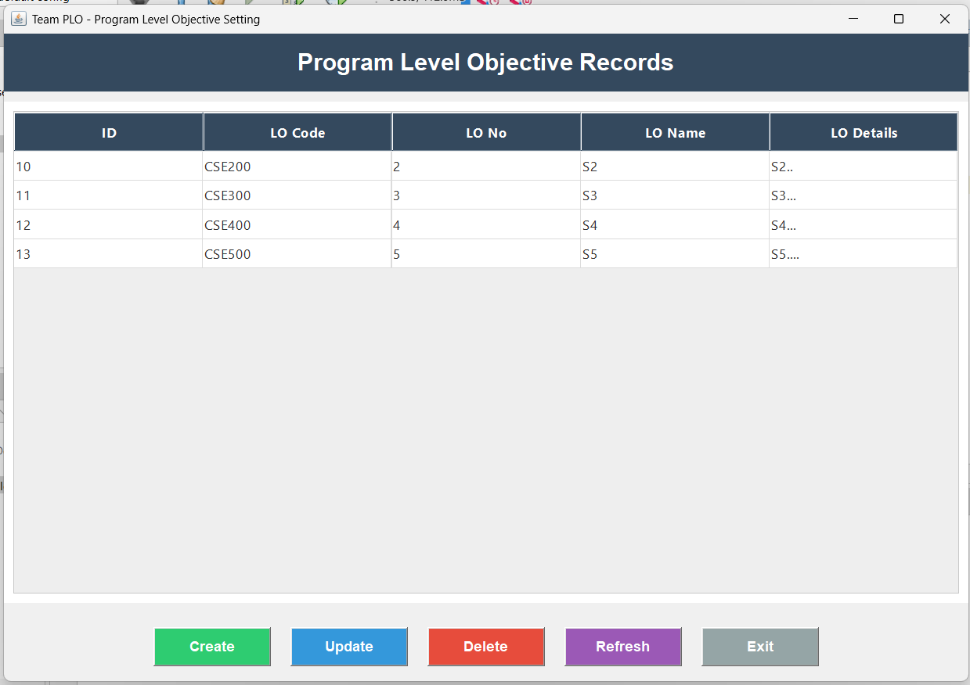
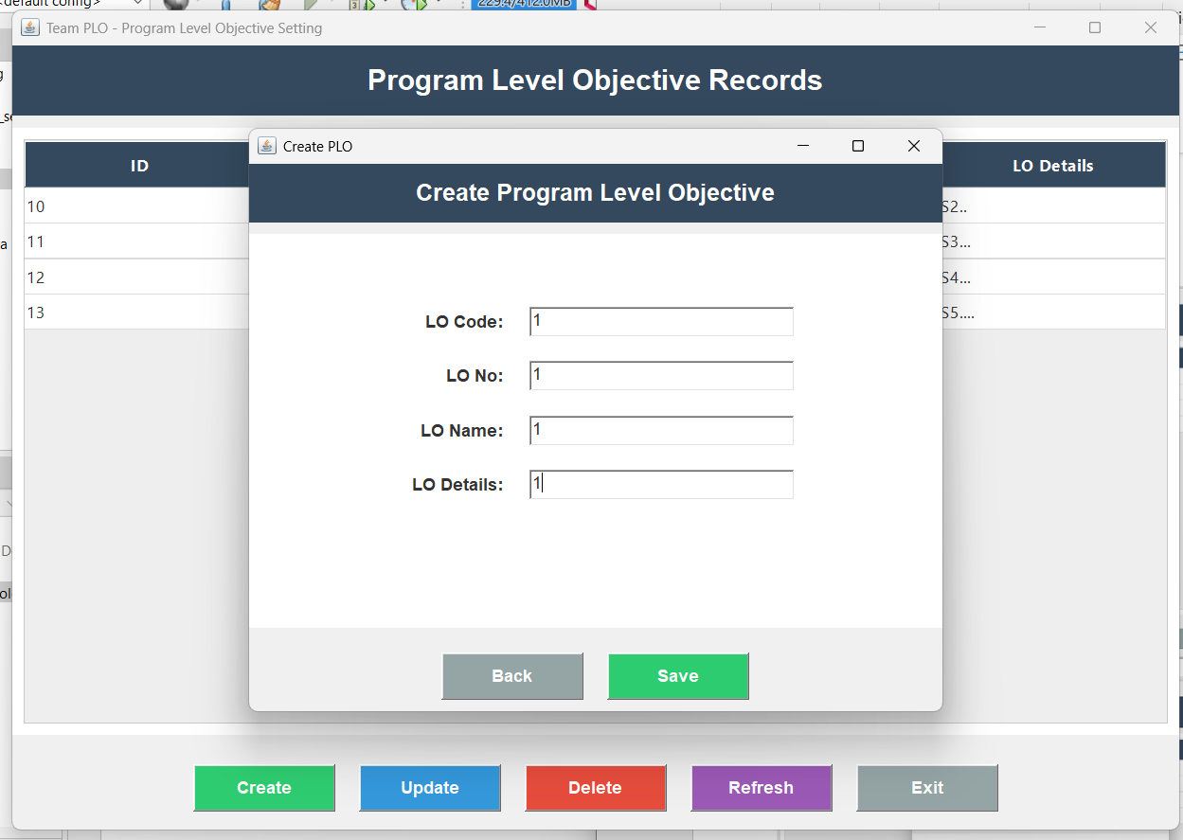
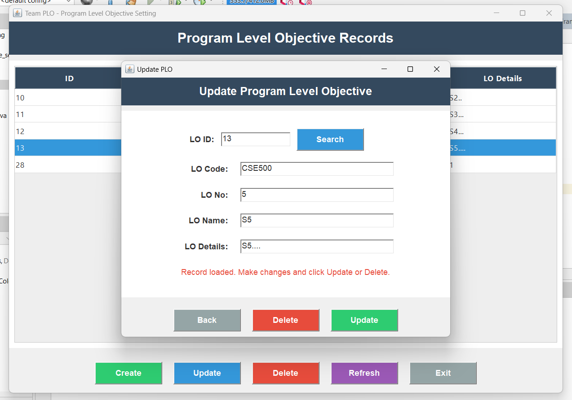

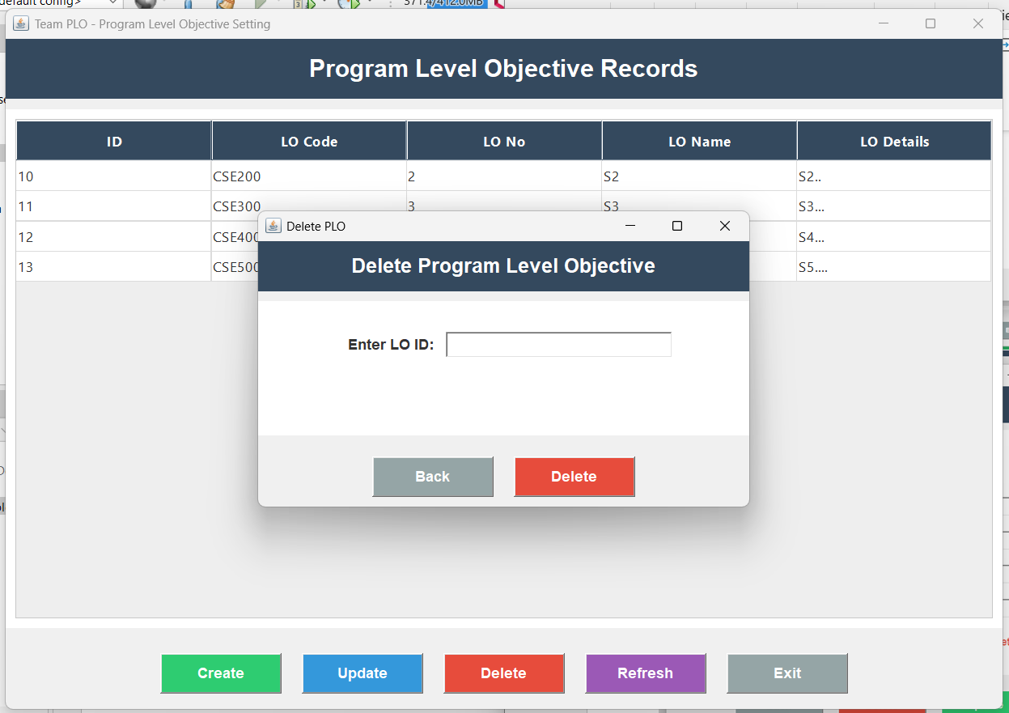

Conclusion
The Program Level Objective Setting module provides a simple and effective way to manage program objectives using Java and SQLite. It supports all basic CRUD operations and helps in organizing OBE-related data efficiently. This project enhanced our understanding of Java GUI development and database handling, contributing to the OBE initiative at SRM University

